
Western International College FZE
BTEC RQF Higher Nationals In Electrical & Electronics Engineering
Unit 4019 – Electrical and Electronic Principles
Semester 1 2025 - 26

In Class Test: Fundamental Circuit Analysis
Date: 27 November 2025
Duration: 6 hours

Instructions To Students:

- There are 8 questions on this question paper.
- Answer all questions.
- This is an open book test where you are allowed to bring only your class notes.
- You are strongly advised to plan your answers
- Silent engineering/scientific calculators may be used provided that data and program storage memory is cleared prior to the examination
- Start each answer in a fresh answer sheet
- Your answers should: clearly present steps to each question and also give critical evaluation, and justify your answer to relevant circuit theory

Outcome | Assessment criteria | Tasks to Achieve | Achived?  Y/N
Analyse circuits with sinusoidal voltages and currents | P2 Analyse RLC circuits, using the principles of circuit theory with sinusoidal sources. | Q1, Q2, Q3, Q4, Q5, Q6, Q7, Q8
 | M2 Analyse RLC circuits, using the principles of circuit theory and mathematical techniques used with  sinusoidal sources. | Q1, Q2, Q3, Q4, Q5, Q6, Q7, Q8
 | D2 Evaluate the operation and behaviour of series and parallel RLC combined circuits, including resonance and using the principles of circuit theory with sinusoidal sources. | Q1, Q2, Q3, Q4, Q5, Q6, Q7, Q8

Student Name
Student Number

- An alternating voltage is given by

v=75sin 200πt-0.25 volts.

Find:
(a) the amplitude,
(b) the peak-to-peak value,
(c) the r.m.s. value,
(d) the periodic time,
(e) the frequency, and
(f) the phase angle (in degrees)

- An e.m.f. of 200V at a frequency of 2 kHz is applied to a coil of pure inductance 50mH. Determine (a) the reactance of the coil and (b) the current flowing in the coil.

- A capacitor has a capacitive reactance of 400 Ω when connected to a 100V, 25Hz supply. Determine its capacitance and the current taken from the supply

- A coil has a resistance of 4 Ω and an inductance of 9.55 mH. Calculate (a) the reactance, (b) the impedance and (c) the current taken from a 240 V, 50 Hz supply. Determine also the phase angle between the supply voltage and current.

- A capacitor C is connected in series with a 40 Ω resistor across a supply of frequency 60 Hz. A current of 3 A flows and the circuit impedance is 50 Ω. Calculate (a) the value of capacitance, C, (b) the supply voltage, (c) the phase angle between the supply voltage and current, (d) the p.d. across the resistor and (e) the p.d. across the capacitor. Draw the phasor diagram.

- A coil of resistance 5 Ω and inductance 120 mH in series with a 100 μF capacitor is connected to a 300 V, 50 Hz supply. Calculate (a) the current flowing, (b) the phase difference between the supply voltage and current, (c) the voltage across the coil and (d) the voltage across the capacitor.

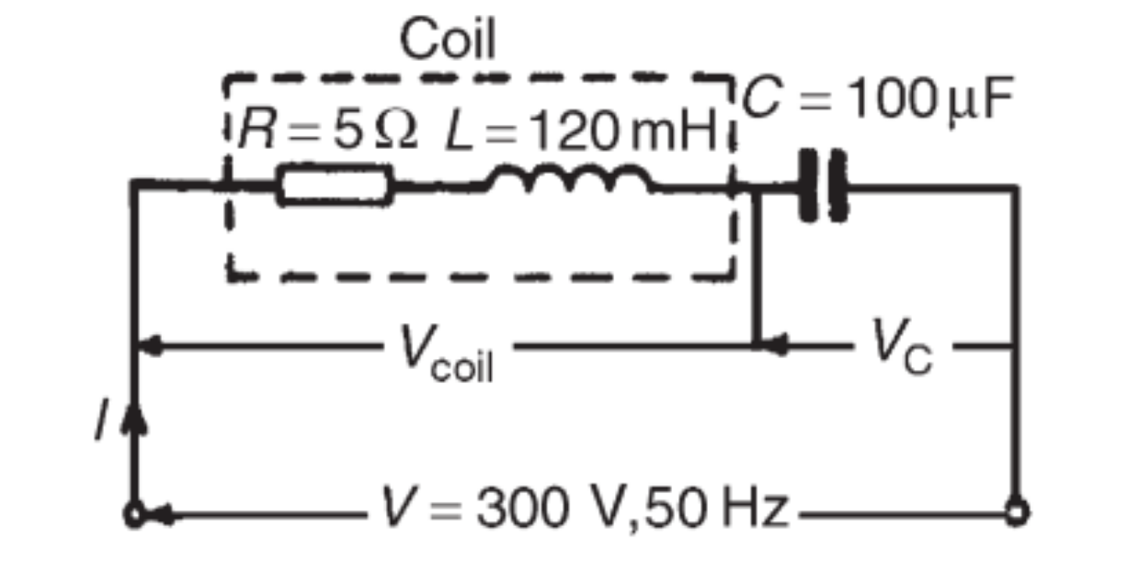

1 Question 6 Diagram

- The current at resonance in a series L–C–R circuit is 100 μA. If the applied voltage is 2 mV at a frequency of 200 kHz, and the circuit inductance is 50 μH, find (a) the circuit resistance and (b) the circuit capacitance.
- The parallel RLC circuit shown below consists of a resistor, inductor, and capacitor connected across a 100 V, 50 Hz sinusoidal supply. The component values are:

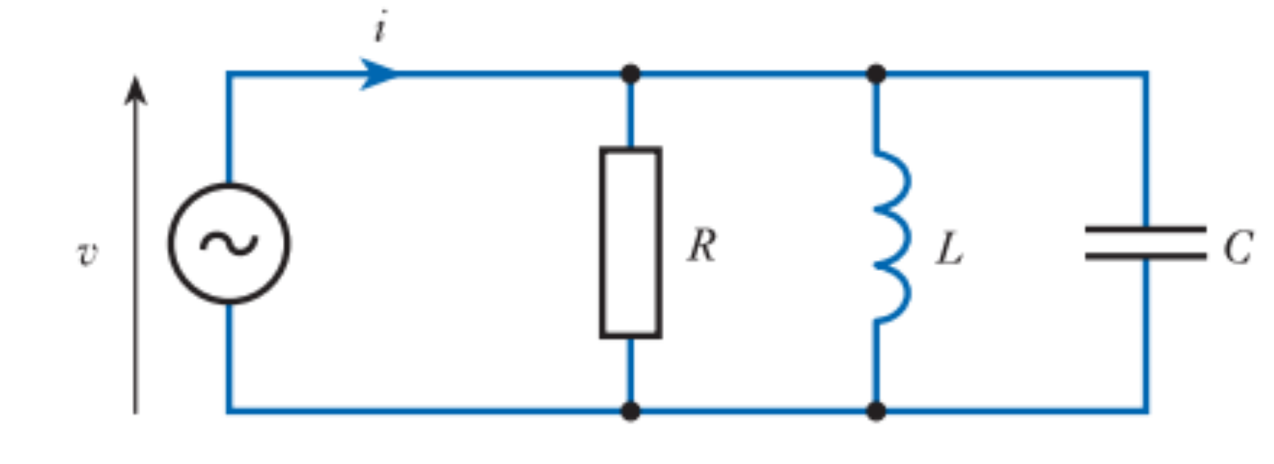
R=150 Ω,L=0.25 H,C=100 F.
Question 8 Diagram

Find:
(a) The inductive reactance and capacitive reactance at 50 Hz.
(b) The total current taken from the supply and its phase angle with respect to the supply voltage.

(c) The resonant frequency at which the circuit current is purely resistive.
(d) The impedance and current at resonance.
(e) Simulate the circuit and evaluate how the circuit behaviour changes below, at, and above resonance, commenting on current magnitude, phase relationship, and power factor.
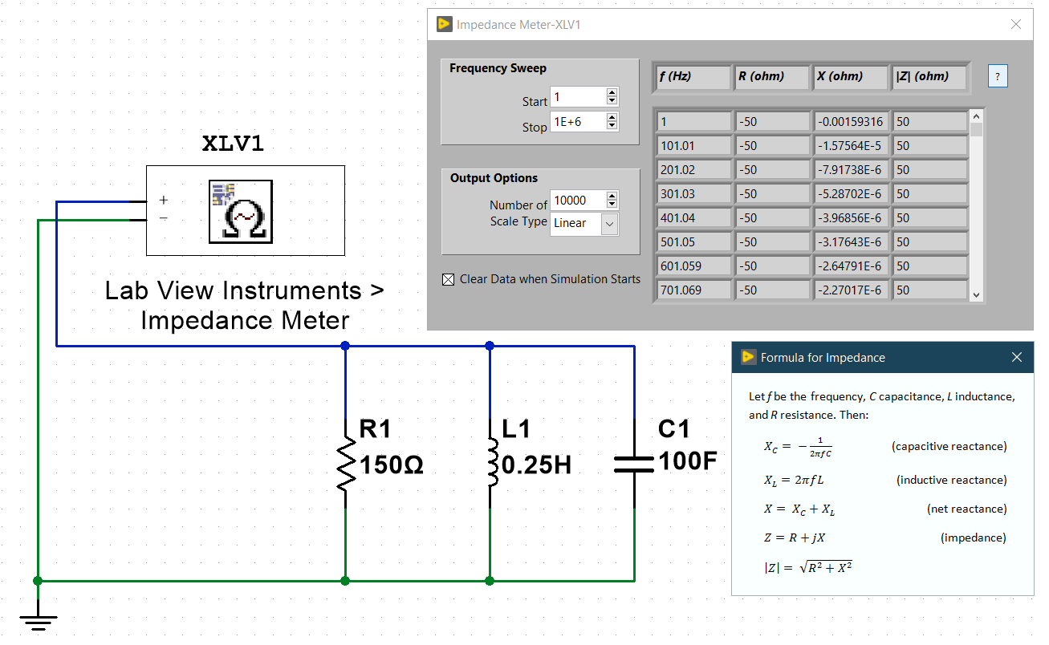
DATA MESEAUREMENTS TABLE APPEARS HERE
“REPLACE THIS IMAGE”
Stop at 1E+8

